Odyssey Card Preview: Atogs
Anthony Alongi
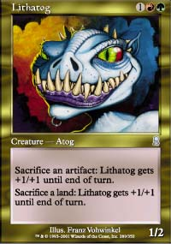
Well, Atogs are back. And before anyone starts pointing any fingers, I had nothing to do with this.
We'll start with the positive attributes. First, any instant-speed ability on a creature that costs no mana and no tapping is worth at least a hard glance. Second, Odyssey is promising two confirmed mechanics - flashback and threshold - that both depend on smart graveyard management. If tools exist to use and reuse the graveyard, sacking permanents becomes more palatable, and possibly even abusable. And third...aw, come on, these guys are so adorable, just look at those iddy-biddy-cutey-wootey-beady-weedy eyes, don't you just want to take them home and feed your small dog to them? (No? Then perhaps you enjoy small dogs more than I do.)

De-Constructing Your Limited Atogs
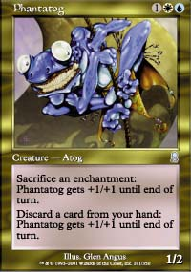
On the negative side, almost every ability involves sacrificing a permanent, without a guarantee of making up the card disadvantage. This typically puts a card well below the upturned nose of the refined professional Magic player. To make matters worse, the only way to make up that card disadvantage is through a "trick" that is plainly visible on the board - I mean, look at the artwork! Every one of these Atogs is sitting there with their own built-in "tell", grinning at your opponent like they can't wait for them to block. And finally, while they are more flexible than old-school Atogs (where you could only sacrifice one thing), they get less of a benefit for each use. The single additional point of damage you do had better be worth it, since you're losing a permanent in the process.
So the atogs come with both charms and difficulties; the trick will be to get their potentially abusable advantages to outweigh their immediate disadvantages. This will be harder in Standard and Block formats than it is in Limited, or maybe Extended. To get a clearer picture of the nuances, it may be easier to look at each ability separately, rather than each Atog:
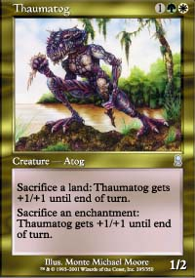
Enchantment sacrifice: Unless there is a device like Verduran Enchantress to help draw cards for each enchantment you play, and/or enchantments like Rancor that swing back to your hand once sacrificed, Phantatog and Thaumatog start with a strike against them. Unlike lands, enchantments don't typically dominate a deck. Local enchantments beg for card disadvantage, and most global enchantments are expensive food for a simple Atog. Globals are typically used for establishing a clear win condition (e.g., Saproling Burst or Worship) - sacrificing them is hardly helpful.
In Extended, an Enchantress deck already using Auratog may spare a thought or two for Thaumatog (especially since the other ability will be easier to use as well, given the amount of lands likely to be drawn). And you can imagine some creative Replenish possibilities in Phantatog's colors. But in Standard or Block, this ability needs serious help. In Limited, the chance you will get an enchantment in your card pool, decide it makes the cut, draw it, play it, and then evolve a situation where it is worth an extra point of damage to get rid of it is... well, small.
That leaves multiplayer environments. Tell you what, I'll save my ruminations on that sort of thing until the end, so there's fair warning. I don't want to burn out anyone's eyes.
Artifact sacrifice: This is basically presents the same problems as enchantments - although artifacts (and especially artifact creatures) are slightly easier to stuff into a deck, and/or bring back from the graveyard. If Odyssey has a Nether Arti-Spirit, bonus for us. Otherwise, give Sarcatog and Lithatog one strike in recent Constructed environments, as well. And as with enchantment sacrifice, this ability alone does not warrant play in Limited environments.
Land sacrifice: This looks a bit more promising, if only because there will nearly always be more lands at your disposal than either artifacts or enchantments. Right now in Constructed, this is still tough to pull off - only decks with Saproling Cluster or (Maher-Oath style) Overgrown Estate dared to sacrifice precious lands in Extended portion of Worlds last month, while the counter-heavy Invasion block format will soon become a blue-heavy Standard format... and counter-heavy decks don't like sacking lands.
But in Limited, lands are more expendable, and a Lithatog or Thaumatog can be a decent three-drop, threatening an "emergency" size of up to 4/5 as soon as it's cast.
Hang on, I'm getting a flash here: Yawgmoth's Agenda in a green-white-black Thaumatog deck for Standard! And add Overgrown Estate! Desolation Angel for win condition! Wait, no, that's all just a bad joke. My bad. Everyone, come back; I promise not to do it again!
(Cut to one office building cubicle, then another, then another. Pro after pro hides his or her face in head-splitting pain. The collective screams of "my eyes!...my eyes!" from computer terminals around the world is deafening. The top 1000 players in the world immediately go blind, and give up Magic. And amazingly, Team Mom Has the Kids... Again still can't qualify for the Pro Tour.)
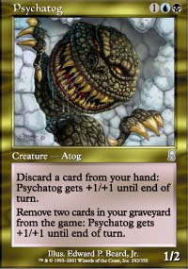
Discard: Experienced players are perfectly comfortable with many discard "tradeoffs", and less so with others. Psychatog and Phantatog can be viewed as forms of spellshapers (Deepwood Drummer, to be precise), which got some Block Constructed play, plenty of Limited play, and virtually no Standard or Extended play. The fact that the discard can be repeated makes them a bit more intriguing in an age where Odyssey's "threshold" mechanic depends on having seven cards in the graveyard. The potential to pump two creatures at once (the Atog, and something with threshold) may make these Limited game-breakers, if your card pool is threshold-friendly.
Graveyard shooting: In the Magic we know and love today, graveyards get chock full of all sorts of cards. With the exception of Yawgmoth's Agenda (and perhaps Pyre Zombie), recursion is a long way from its heyday in Rath and Urza blocks. While Odyssey hints at more involved graveyard management, Sarcatog and Psychatog get a boost over other atogs from this superior ability, as already spent cards are the easiest resource to give up. (That's why you have to purge two cards, whereas the other abilities only require one.) The extra cost is easily worthwhile, and both of these Atogs will range from worthy to excellent in your sealed or draft deck.
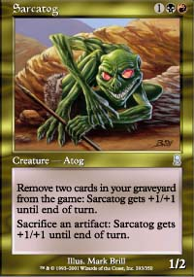
In constructed, Psychatog shows a bit of actual synergy between its two abilities here, as every two cards in your hand can now represent a Giant Growth. That's not exactly the dynamic most constructed blue-black decks are digging for; but a determined effort to use atogs in Standard or block constructed should probably look at Psychatog first. While Sarcatog theoretically has similar potential (sacrificed artifacts, after all, do go to the graveyard, last time I checked), the red-black Constructed deck that can pump enough artifacts into and out of play to power a three-casting cost, 1\2 creature to victory has yet to rear its (machine?) head.
So let's put these atogs back together, and see how they stack up.
I'd suggest the Psychatog as the most useful and consistent blend of abilities across any serious format. It even matches the colors of the well-previewed Shadowmage Infiltrator, which - what do you know - gets you more cards. That may or may not be enough to get into a serious Constructed deck. Sarcatog may be better suited to the creature-pump ability, given its colors; but without either a reliably recurring artifact creature or a set of quick, small artifact creatures, this one should rank a distant second. Thaumatog, Lithatog, and Phantatog all cluster closely behind, blending a more or less reliable ability (land sack for the first two, discard for the third) with a highly conditional one (artifact or enchantment sacrifice). All of these creatures will look fine in Limited; but they all will also need serious help from other Odyssey block cards to help them work in Constructed.
Now let's look at these freaks from a casual standpoint.

Feeding Atogs at Your Dinner Table
When it comes to casual play, there's a rule we group mavens live by: "keep your friends close, and your Atogs even closer."
Okay, right there, I lied. That rule doesn't exist. I don't even know what it could possibly mean.
But if I haven't completely betrayed your trust with my little fib, perhaps I could share some thoughts on a deck or two that might look good at home in the kitchen, when you're playing with three or four other players. Atogs, after all, were almost certainly reintroduced for casual play. And so let's celebrate them in that environment.
I've chosen the Psychatog and Sarcatog as my subjects for these little experiments. That's largely because I can't stand Replenish or Enchantress decks, while the cards that let you recur lands are few and far between (and white).
PSYCHOUT.DEQ
4 Psychatog
4 Shadowmage Infiltrator
3 Phyrexian Infiltrator
2 Thieving Magpie
4 Wall of Fog
1 Ephemeron
4 Seal of Doom
4 Seal of Removal
4 Prosperity
4 Dark Suspicions
2 Probe
4 Underground Sea
2 Remote Isle
2 Polluted Mire
10 Island
8 Swamp
The Seals and Phyrexian Infiltrator are warning signals to opponents; the Shadowmage and Magpie ping away for card advantage; Prosperity and Probe give you card drawing; and your path to victory is either long-game Pyschatog beatdown or Dark Suspicions. The Ephemeron is a bit of a joke; why don't you put in another Magpie?
SARCASTIC.DEQ
4 Sarcatog
4 Fallen Angel
4 Bloodfire Kavu
4 Ornithopter
4 Phyrexian Walker
4 Shield Sphere
4 Ghitu War Cry
4 No Rest for the Wicked
4 Urza's Rage
This deck updates an old casual stand-by: 0-cost artifact creatures and Ghitu War Cry. Now, Fallen Angel and Sarcatog can get stronger at instant speed by shoving them into the graveyard. No Rest for the Wicked can put them back into your hand for easy replay. Urza's Rage is for when your amazing Atog-based strategy fails completely.

Goodbye Atogs...or Is It?
Ironically, even with my casual reputation, I've never cared much for Atogs. I always felt they did too little, for too much cost. I like that this new batch of Atogs is a bit more flexible, if perhaps still a bit underpowered. They're worth messing with, for a little while. But will they then sit in our boxes, a-twiddling their a-toggy a-thumbs?
Odyssey promises to be a graveyard-friendly expansion. The recursion tools exist, the more innovative we will be with our little Atog friends. Keep them handy, after you've offered them a balanced breakfast, and watch carefully as the entire Odyssey block rolls out for opportunities to make them more effective. Perhaps after an expansion or two, one Atog will find a niche in a completely new Standard or Block archetype. Perhaps another one will find a regular game-breaking role in sealed. And perhaps one will interact with four intricately balanced enchantments to become the rage at five-player chaos games around the globe.
Or perhaps we'll just feed them all to the next creature I preview... coming soon.

